Ok so now we are going to finally build this game for our Android device, so let’s get started

No e go to file > Build settings Now make

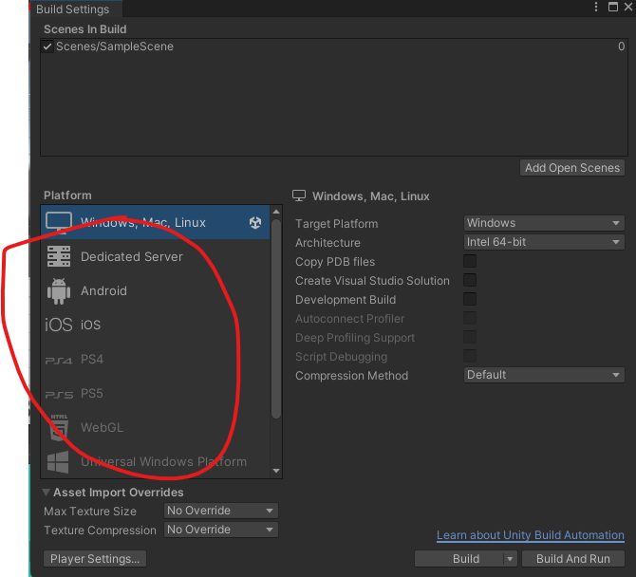

Now click on Add Open Scenes

Make sure the scenes are added to the game

Now in marked come area that is platform select Android then the right area will be updated Now click on switch platform so that we can build for our game for android

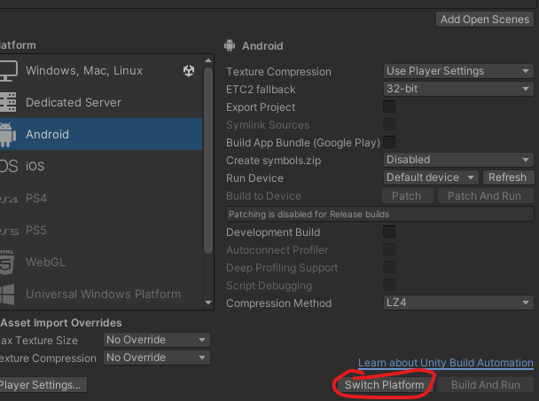

Now the unity symbol is beside the Android as shown below

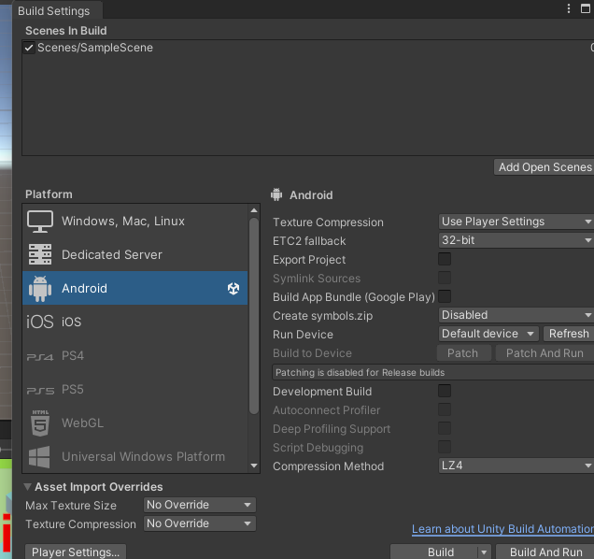

And before doing all this, before actually trying to convert it to Android, you need to make sure

that you have set up all the necessary things that( maybe before ) you need to convert to Android.(who knows)

OK, so as you can see, our build has converted to Android.

before converting it to Android, you need to go to

Edit> preferences.

1:00

Now a window will be opened

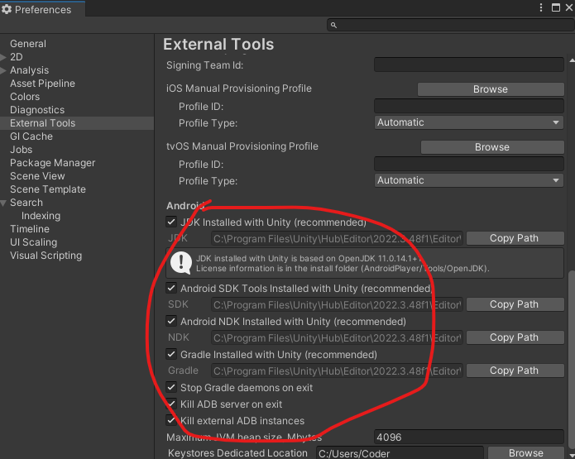

Now go to External Tools side tab and make sure that SDK is set to the android SDK and JDK is said to be connected to java development kit that we have installed download and installed and set it tup

So you need to make sure these things are correctly set up only then this will convert them(App) to android

**Note:-**

We have set the resolution for the game as 16:9

Now our game goes perfectly

Now lets build that To build that just go to File > Build Settings

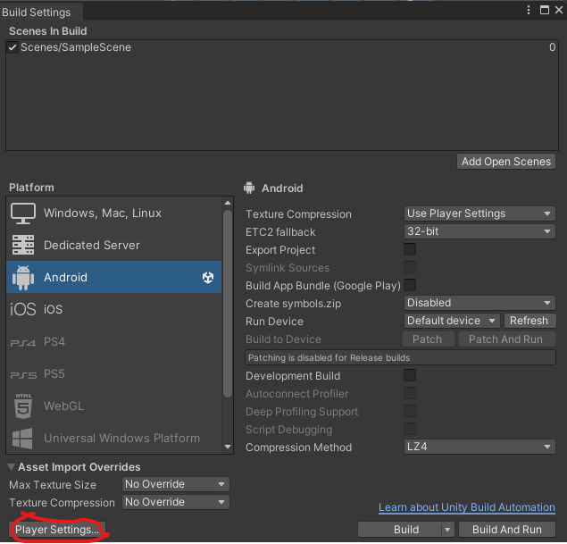

And the new window will be opened now go to Project setting ( may be to set the setting of the project )

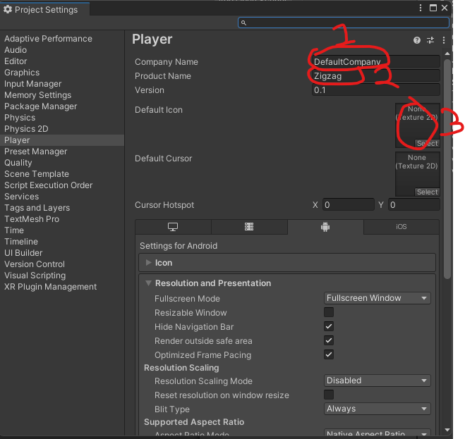

In marked one tell the company name in the marked 1 ( I name it Trinity you can tell the product name that is going to be built that is our game name we name it Zig zag and In marked 3 we set the icon for the game Teacher set it as default but if you are publishing the game you should already also give it an icon that you create. I am adding an icon image for the game that is this 

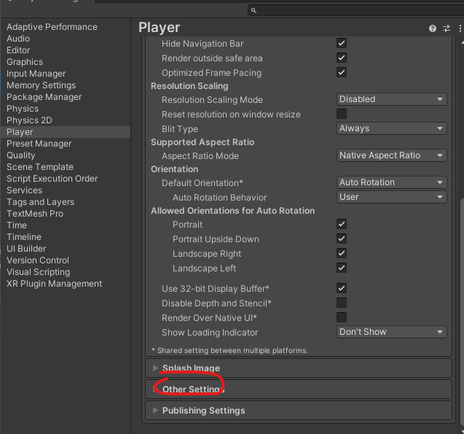

No scroll to the bottom and then expand the other setting as marked above

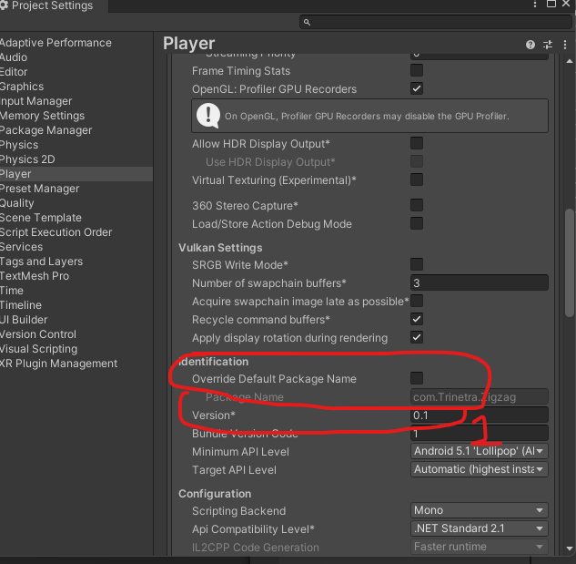

And then go to Identification as marked above you can override the default package name by checking its respective checkbox but you can leave it uncheck if you want the name of the package to be set as default set by the software I keep it as default (I think this package contain all our game code we wrote)

You need to make sure that you need to make sure that this bundle identifier is unique Among all the apps available in Appstore. This Bundle identifier should be unique ( I think this package is like an identifier for them maybe because maybe all the apps packages are saved in same place then they cannot coexist because both of them have same name that’s why every app should have same name))

So that is why you will write for all your games com.<Company name>.<Game name> so that it become unique( who will do research later )

Now in marked 1 you can wite the version you have(I think it may be used for version control(who knows)). I you are upgrading from n old version to new version then you can change the version to 0.2 or maybe any other number you want you think is proper

And from here you expand the resolution and Presentation as marked below

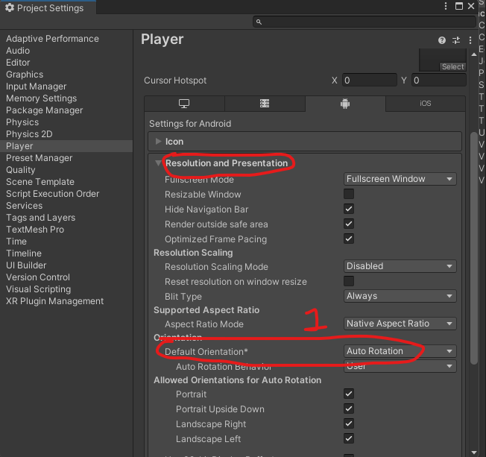

We have this auto rotation chosen as the default rotation

Now below s the check box telling what are the orientation you could take while rotating the phone when autocomplete is chosen

We uncheck all except Portrait by this we choose portrait orientation so we want our game to be in portrait mode as marked 1 above

now go to the default orientation and then set it to portrait from auto rotation

So auto rotation is off and portrait is now our default rotation as marked below so our game will now be in portrait mode only

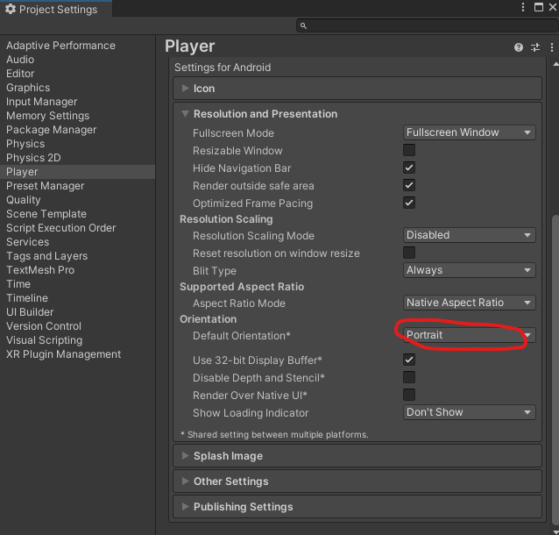

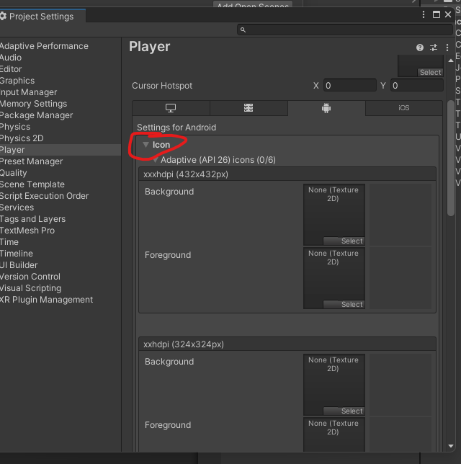

You can click on marked icon above

ATT we can give any icon to your game ( which we have given previously I don’t know ahy we want to set it again )

You can give different icon for different stores and different location of the store (I don’t know what it is) (maybe they are icons for different sized device (who knows))

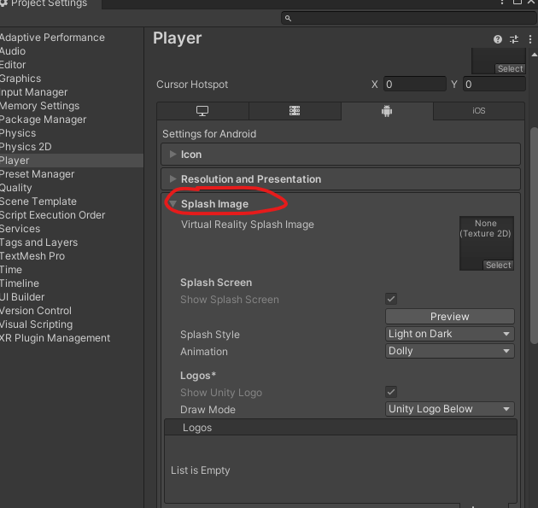

You can click on the splash image as marked above which is not available in the personal edition of the unity it is available in the pro edition and

We go to Publishing settings a marked below

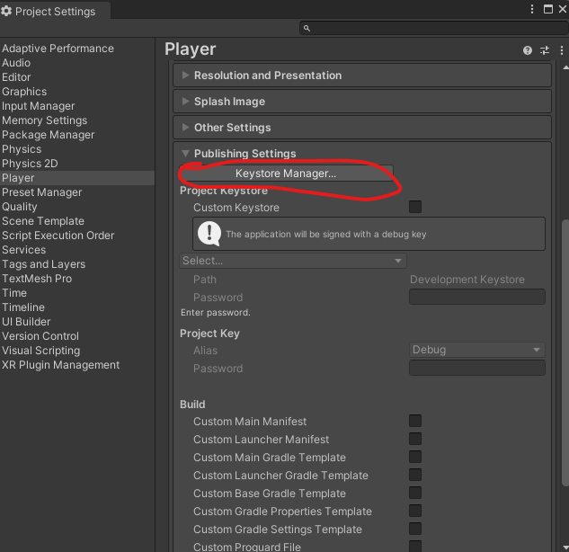

from here if you are publishing it to Google Play Store then you need to add a key store to your game (I don’t know) otherwise not

If you are publishing to Google Play store, then you either need to create a new key or you need to browse your keystore(I don’t know).

(In new ui click on Keystore manager

And then key manager will be opened

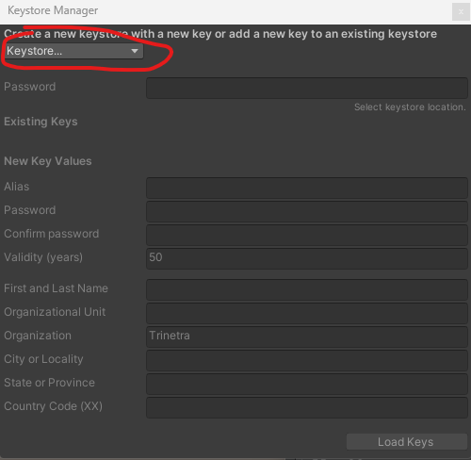

Now go to marked option to show you options for creating new key or browse already existing key)

That means if you already have published in Google Play then you already have a key store

Just add that and publish the game

Just make sure your scene is added

Now close all other windows except main or Build setting window

And then click on Build button as marked below

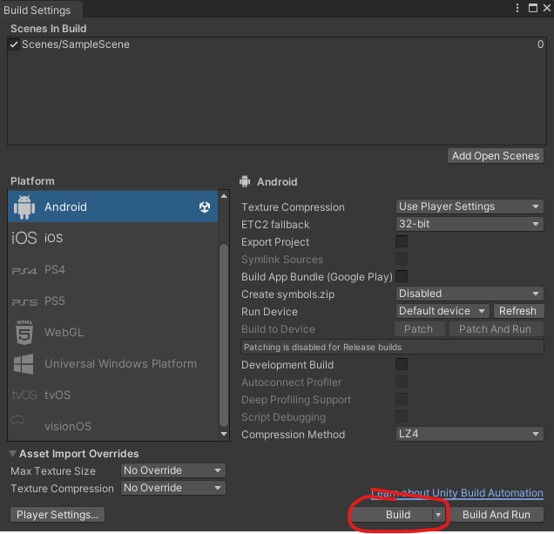

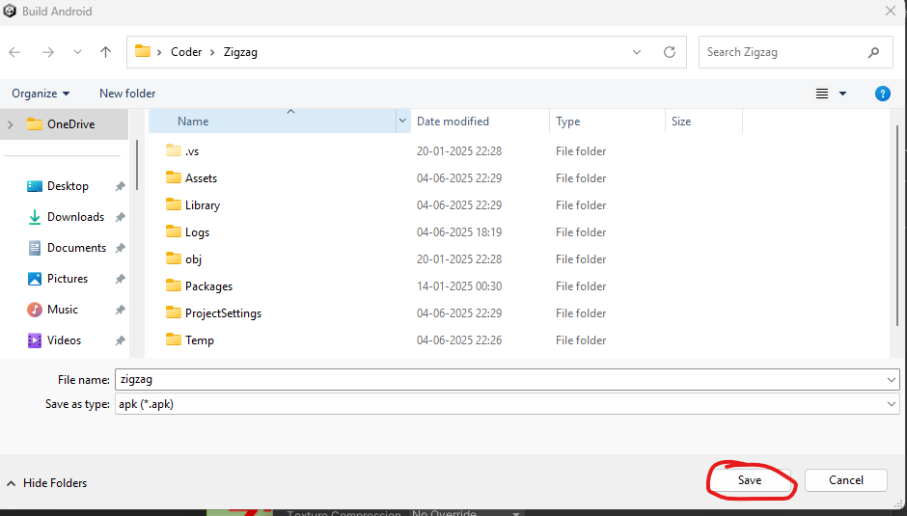

Now a brose window will appear as shown above and give it a name and just make sure where you are saving it and then click on save button as marked above

So afeter that it will build in apk and we will test it

_________________________________________________________________________________

**Revision Note:-**

Remember to add icon for the game

First create icon folder inside Assets folder

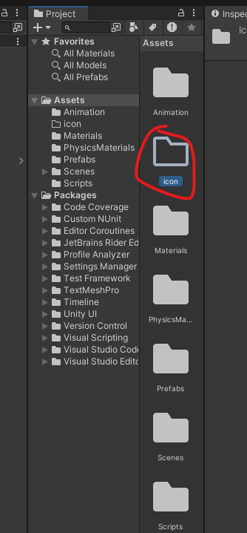

Inside this folder bring the image by dragging it from the folder where the image is present and drop it on the folder icon as shown below

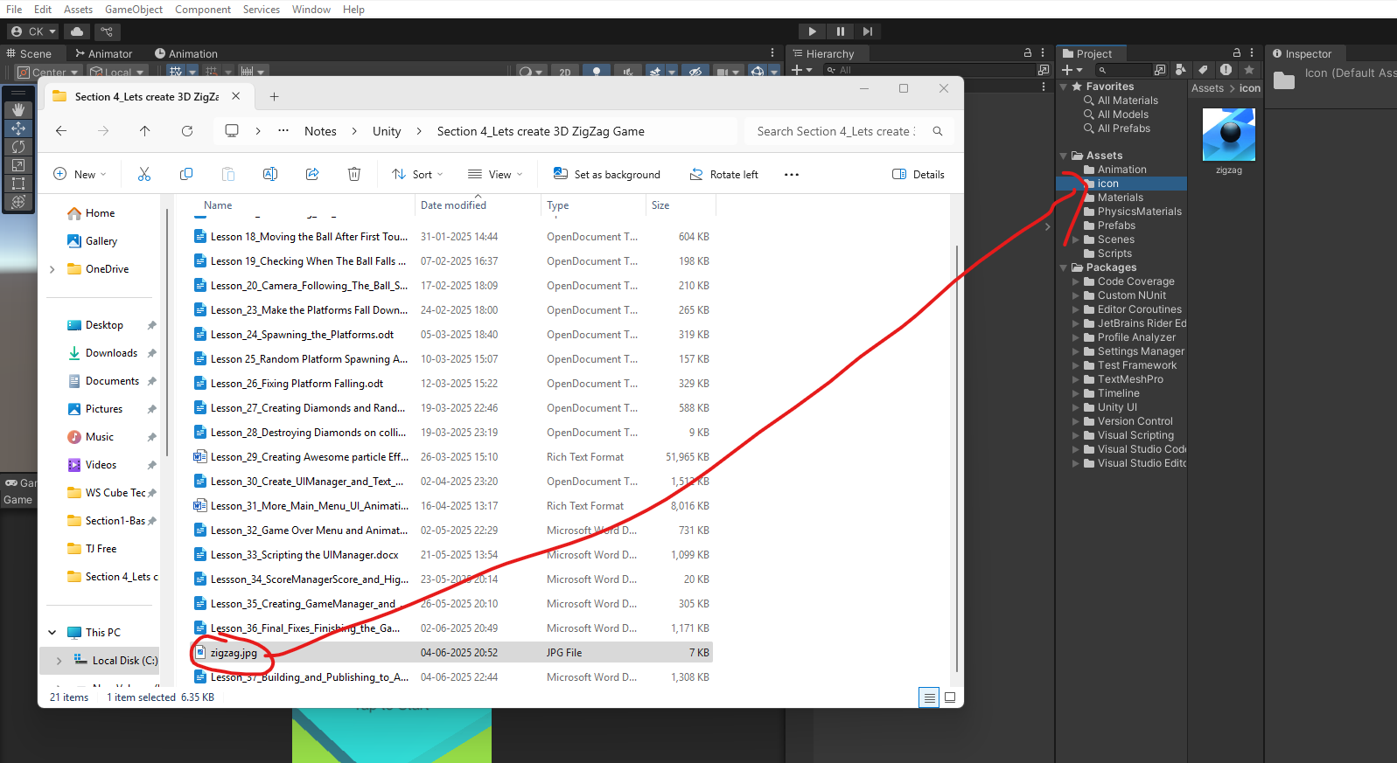

Now open build setting

And then to project setting now drag your image from icon folder in project panel of unity editor to the default icon in the project setting as shown below

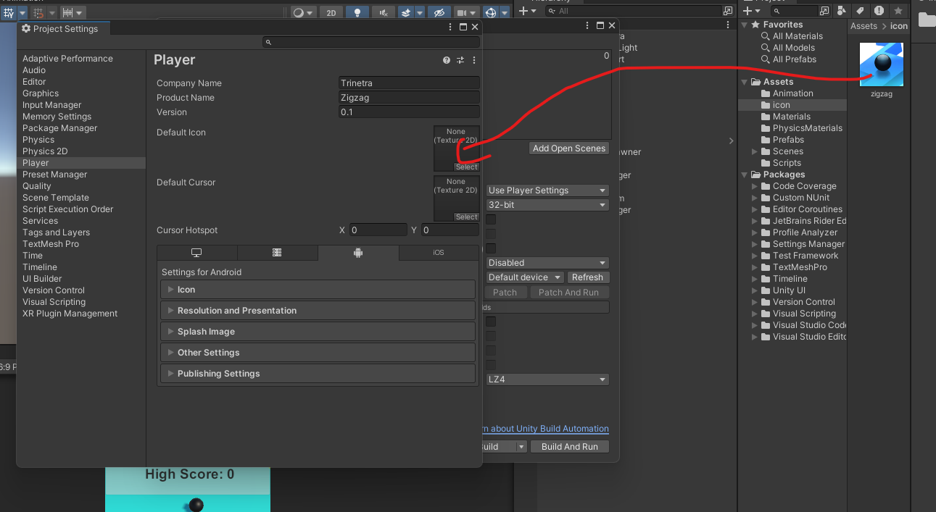

Now in you can see the icon added as marked below

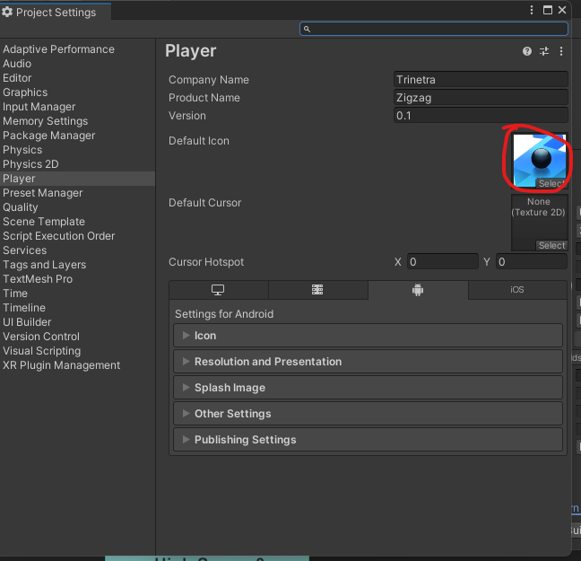

__________________________________________________________________________________

5:25

It may take some time to build . < A loading screen is shown to tell how much it is built > Ok so now our game is built and any time you can just out these file in your apk file and just test the game.

So this is how we can publish our game to Android platforms

And if you want to publish for PC then in your build setting switch to **Windows, Mac, Linux** as marked below . you don’t even have to switch as it is the default platform

**Have fun and publish it to Google Play store and other app store**

